**1.qualcosa Effort and Duration Estimation with COCOMO II Method**

Once estimated the dimensions of the system-to-be, it is possible to make a first prevision of the software cost in terms of time spent and people allocated to the project.

The COCOMO (Constructive Cost MOdel) approach is based on effort and duration estimation using ad-hoc formulae that consider many parameters derived from previous projects data and future previsions.

The formula used for effort calculation is the following:

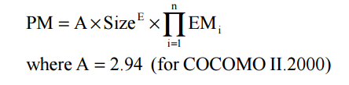The effort is calculated in Persons-Month; in this case, the parameter Size is derived from the Function Points evaluation done before, E and EM are factors derived from respectively scale factors and cost drivers, i.e. elements that let the project manager consider the system necessities and have a preview of what the team needs to deal with.

The exponent E is obtained from the following expression:

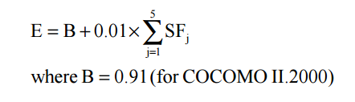SF are the mentioned scale factors, consider elements like developers experience, team cohesion, and project specifications.

Their value is decided with the help of the dedicated table.

Let’s analyse them in detail:

Precedentedness:

It reflects the previous experiences related to this kind of projects. In this case the team had already developed similar systems so the nominal value will be reflecting the actual situation.

Development flexibility:

It reflects the flexibility of costraints in the development process. The stakeholders set

precise specifications but without letting the development team free to choose the majority of implementation details, for this reason this value will be nominal.

Risk resolution:

Reflects the extent of risk analysis. A well developed risk management plan corresponds to a high value in the table. In this case the value considered is nominal.

Team cohesion:

Reflects how the development team know each other and cooperate. In this case the team is united; people communicate and cooperate in an efficient way, so it is possible to consider a high value for this parameter.

Process maturity:

Reflects team maturity regarding project development management. Organization and adopted techniques influence this factor. For this project, the correct value is the nominal one since the project is developed under standard conditions.

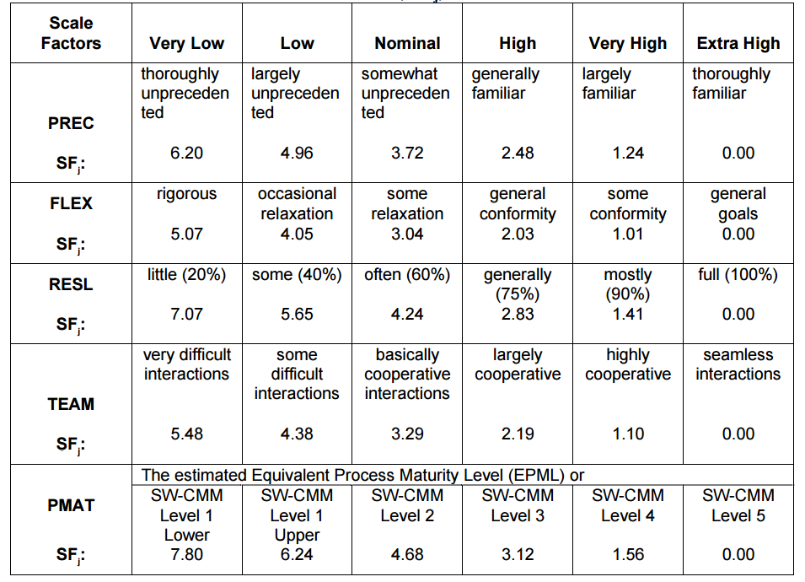

In this particular project the values considered are often the ones in the “Nominal” column, since the project conditions are standard and often idealized. The only higher value is the one regarding Team Cohesion.

With the chosen factors, we can calculate the exponent E with the already presented formula.

E = 0.91 + 0.01 x (3.72 + 3.04 + 4.24 + 2.19 + 4.68) = 0.91 + 0.01 x 17.87 = 0.91 + 0.1787 ≈ 1.08

Now it is necessary to calculate effort multipliers, and it is done in the same way used for scale factors, using the dedicated tables.